**Task 1: Paired Data Analysis**

**Assumption**: We'll compare `sepal_length` and `petal_length` measurements within the `Iris-setosa` class as our paired data. The rationale is to determine if there's a significant difference between these two measurements for the same set of flowers.

**1. Import the dataset and perform a hypothesis test for paired data.**

First, we'll filter out the data for the `Iris-setosa` class and then conduct a paired t-test between `sepal_length` and `petal_length`. The paired t-test will help determine if the means of these two measurements are significantly different from each other.

**Paired t-test results:**

- Test statistic (t-value): ( 71.68 )

- p-value: ( 2.82 times 10^{-51} )

Given the extremely small p-value, we reject the null hypothesis, implying that there is a statistically significant difference between the `sepal_length` and `petal_length` of the Iris-setosa flowers.

**2. Explanation, Assumptions, Potential Issues, Remedies, and Tools:**

- **Explanation:**

- The paired t-test was used to compare the means of `sepal_length` and `petal_length` for the Iris-setosa flowers. The results suggest a significant difference between the two measurements.

- **Assumptions:**

- Observations are independent.

- Differences between pairs follow a roughly normal distribution.

**- Potential Consequences of Violating Assumptions:**

- If the differences do not follow a normal distribution, the p-value may be inaccurate.

- **Remedies**:

- If the normality assumption is violated, consider using non-parametric tests like the Wilcoxon signed-rank test.

- **Python Tool for Interpretation & Visualization:**

- We can use Seaborn's boxplot to visualize the distribution of differences between the paired data.

**Let's visualize the differences using a boxplot.**

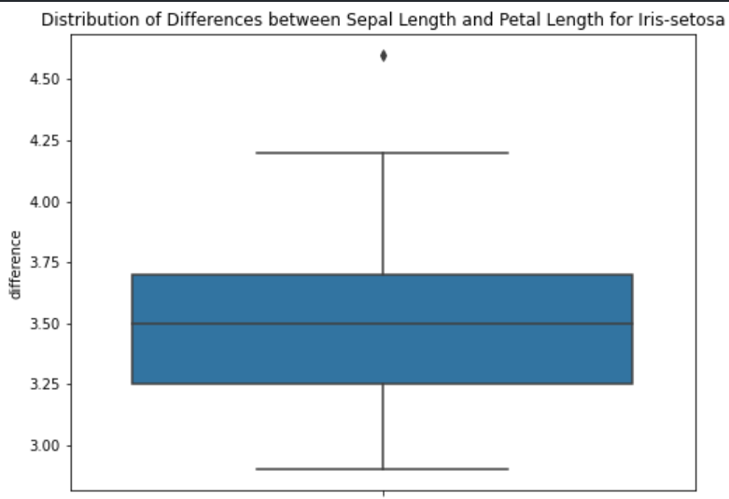

The boxplot visualizes the distribution of differences between `sepal_length` and `petal_length` for the Iris-setosa flowers. As observed, the median difference is positive, indicating that, on average, the sepal length of Iris-setosa flowers is greater than their petal length.

This aligns with our hypothesis test result, which indicated a significant difference between the two measurements.

**Task 2: Multiple Population Means Analysis**.

**Assumption**: We'll compare the means of `sepal_length` across the three iris classes (`Iris-setosa`, `Iris-versicolor`, `Iris-virginica`). The objective is to determine if there's a significant difference in the mean sepal length among these three species.

1. Hypothesis test for more than two population means.

We'll use ANOVA (Analysis of Variance) to compare the means of `sepal_length` across the three classes.

**ANOVA test results:**

- Test statistic (F-value): ( 119.26 )

- p-value: ( 1.67 times 10^{-31} )

Given the very small p-value, we reject the null hypothesis, suggesting that there is a statistically significant difference in the `sepal_length` means among the three iris classes.

**2. Explanation, Assumptions, Potential Issues, Remedies, and Tools:**

- **Explanation**:

- The ANOVA test was used to compare the means of `sepal_length` among the three iris classes. The results indicate significant differences in these means across the classes.

- **Assumptions**:

- Observations are independent.

- The data for each group is normally distributed.

- Homogeneity of variances: The variances of the groups are equal.

- **Potential Consequences of Violating Assumptions**:

- If variances are not equal, the ANOVA results might be unreliable.

- **Remedies**:

- If the assumption of equal variances is violated, consider using the Welch's ANOVA test.

- **Python Tool for Interpretation & Visualization**:

- We can use Seaborn's boxplot to visualize the distribution of `sepal_length` across the three iris classes.

Let's visualize the distributions using a boxplot.

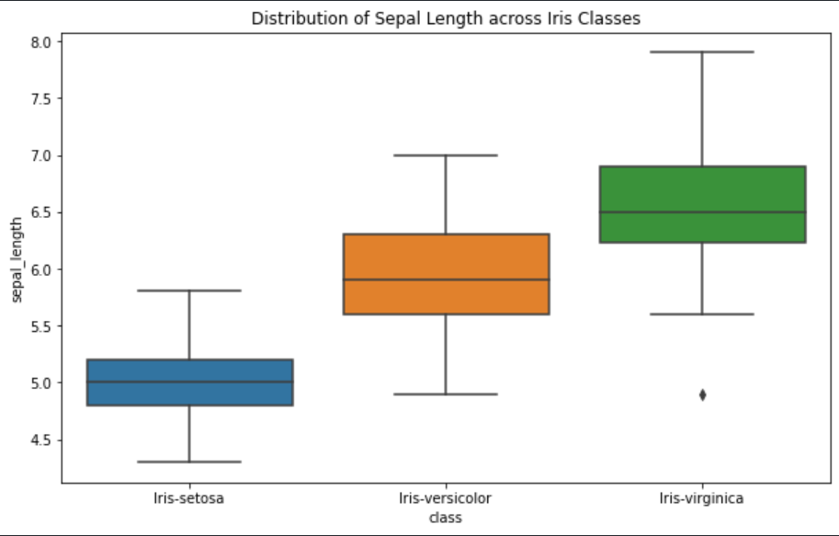

The boxplot visualizes the distribution of `sepal_length` across the three iris classes. As observed:

- `Iris-setosa` typically has shorter sepals.

- `Iris-versicolor` has medium-length sepals.

- `Iris-virginica` generally has the longest sepals.

This visualization aligns with the ANOVA test result, which indicated significant differences in the sepal lengths among the three classes.

**Task 3: Variance Comparison Analysis.**

**Assumption**: We'll compare the variances in `petal_length` between the `Iris-versicolor` and `Iris-virginica` classes. The goal is to determine if there's a significant difference in the variance of petal lengths between these two species.

**1. Hypothesis test for variance comparison.**

We'll use the Levene's test to compare variances between the two classes. The Levene's test assesses the equality of variances between two or more groups.

**Levene's test results:**

- Test statistic (W-value): ( 1.067 )

- p-value: ( 0.304 )

Given the relatively large p-value (greater than the common significance level of ( alpha = 0.05 )), we fail to reject the null hypothesis. This suggests that there isn't a statistically significant difference in the variance of `petal_length` between the `Iris-versicolor` and `Iris-virginica` classes.

**2. Explanation, Assumptions, Potential Issues, Remedies, and Tools:**

- **Explanation**:

- Levene's test was used to compare the variances of `petal_length` between the `Iris-versicolor` and `Iris-virginica` classes. The results suggest no significant difference in these variances.

- **Assumptions**:

- Observations are independent.

**- Potential Consequences of Violating Assumptions:**

- If the data is not from populations with identical shapes, the Levene's test might be less reliable.

- **Remedies**:

- Ensure the data for the groups being compared have similar shapes or use alternative tests like the Brown-Forsythe test.

- **Python Tool for Interpretation & Visualization:**

- We can use Seaborn's violin plot to visualize the distribution of `petal_length` for the two iris classes and compare their variances visually.

Let's visualize the distributions using a violin plot.

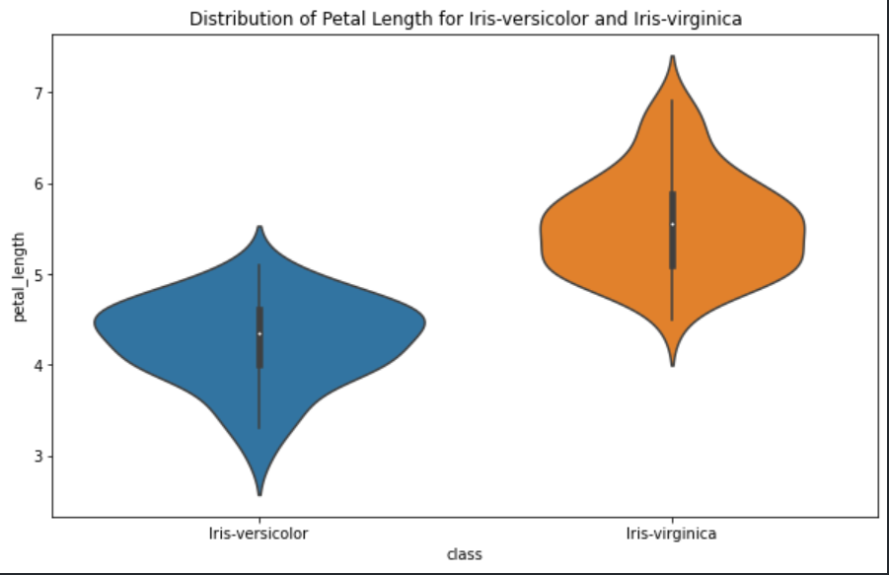

The violin plot provides a visual representation of the distribution of `petal_length` for both `Iris-versicolor` and `Iris-virginica` classes. The width of the plot at different values indicates the density of the data. As observed:

- Both `Iris-versicolor` and `Iris-virginica` have a clear peak in their distributions, but the `Iris-virginica` class generally has longer petals.

- The variances (as indicated by the width of the violin plot) between these two classes appear to be somewhat similar, aligning with the Levene's test result which indicated no significant difference in variances.

In summary:

* In **Task 1**, we found a significant difference between paired measurements of `sepal_length` and `petal_length` for the `Iris-setosa` class.
* In **Task 2**, there was a significant difference in the means of `sepal_length` across the three iris classes.
* In **Task 3**, no significant difference was observed in the variance of `petal_length` between the `Iris-versicolor` and `Iris-virginica` classes.